Innovation Disclosure Form – Guardian Yan

1. Title of the Invention

Guardian Yan – Advanced Vehicle Safety and Emergency Response System

2. Problem Solved by the Invention

The primary problem solved by Guardian Yan is the delayed detection and response to vehicular accidents. Current systems often depend on manual intervention or external monitoring, which can result in delayed emergency response times, especially in rural or isolated areas. There is also limited integration with advanced communication and tracking systems, leading to inefficiencies in providing accurate, timely information to emergency services.

3. Detailed Solution Provided by the Invention

Guardian Yan addresses this problem by implementing a real-time vehicle monitoring system that detects sudden changes in dynamics (such as rapid deceleration or abnormal movement). Upon detection of a potential accident, the system automatically sends emergency alerts to predesignated contacts and authorities. These alerts include real-time GPS data and continue to update until the vehicle is recovered or the alert is cancelled.

Schematics Diagram

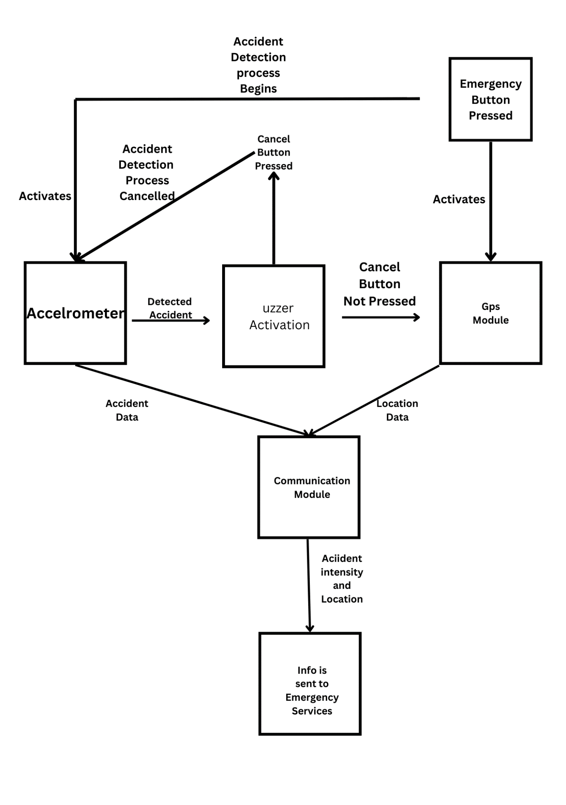

Description: The system operates through a control unit embedded in the vehicle, which constantly monitors data from the vehicle's internal sensors. When an accident or critical event is detected, the communication module activates, transmitting the vehicle’s location and status to both local authorities and designated contacts. The user can also manually trigger an emergency alert or cancel false alarms using a user-friendly interface.

4. Existing Solutions for the Problem

Current solutions in the market rely on:

SOS Emergency Button: This feature is primarily implemented in European cars. Upon pressing the button, the vehicle connects directly to an operator, allowing the user to explain the situation. In cases where airbags are deployed, the system automatically initiates a connection to emergency services.

Basic collision detection systems that trigger in vehicle alarms.

Manual emergency notification systems, requiring the driver or passenger to call for help.

Some advanced vehicles may have integrated emergency assistance systems (e.g., OnStar), but these are generally limited to premium vehicle brands and do not provide a flexible, modular approach.

5. Uniqueness of the Solution

The uniqueness of Guardian Yan lies in its fully automated approach that seamlessly integrates real-time tracking, automated emergency response, and modular design. Unlike existing solutions, it offers a dual mode system with both automatic detection and manual emergency trigger options, allowing for better control in various scenarios. Its ability to continue sending real-time GPS data even after an accident occurs is an improvement over current systems that may not maintain a connection once the event is triggered.

6. Advantages of Guardian Yan

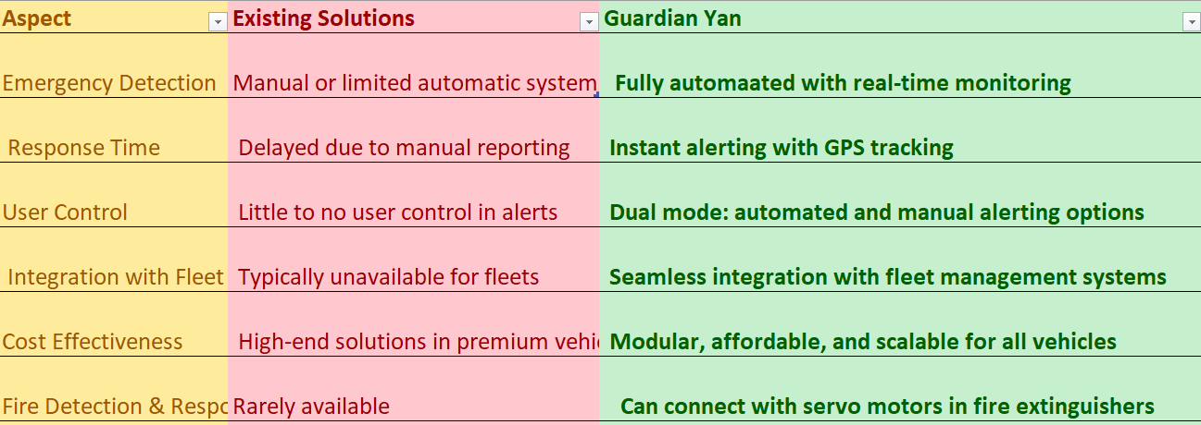

Economic Potential:

Guardian Yan can be integrated into both personal vehicles and commercial fleet systems, creating wide applications in personal safety, logistics, and road safety enforcement. The cost effectiveness and modularity make it viable for mass adoption in both consumer and industrial markets. The added fire prevention feature enhances its value in logistics, especially when transporting goods.

7. Alternative Solutions

An alternative solution could be the use of external monitoring services that track vehicles remotely through third-party services. However, these services often require subscription fees and may not provide real-time response. Additionally, they lack the flexibility and control Guardian Yan offers with its dual mode system and user triggered alerts.

8. Novel Aspects Requiring Protection

Realtime automated accident detection system with continuous GPS tracking.

Dual mode emergency response system, allowing both automatic and manual activation.

Modular design that integrates seamlessly with personal and commercial fleet vehicles.

Realtime location update loop, ensuring continuous tracking post incident.

Pre-emptive alert cancellation mechanism, allowing users to cancel false alarms within a time window.

Automated fire prevention integration, connecting to fire extinguishing systems when needed.

These features differentiate Guardian Yan from existing vehicle safety systems by offering both enhanced automation and user control.

9. Environmental Issues

No significant environmental issues were encountered during the development or deployment of the Guardian Yan system. The components used are environmentally friendly and can be integrated with existing vehicle electronics without requiring extensive modification or additional energy consumption.

10. Innovative Features

Continuous real-time monitoring for dynamic changes.

Pre-emptive alert system with cancellation options.

GPS location update every 12 minutes post incident.

Modular and scalable design, adaptable to various vehicle types.

Integration with fleet systems for route optimization and tracking.

AI driven analysis of accident patterns based on time of day, season, and environmental conditions in specific areas.

11. Utilities/Applications of the Invention

Personal Vehicles: Enhance driver safety and emergency responsiveness.

Commercial Fleets: Provide real-time tracking and accident response for logistics.

Emergency Services: Enable quicker, more accurate dispatch to accident scenes.

Insurance Industry: Improve claim processing with real-time accident data.

Road Safety Agencies: Integrate with smart city infrastructure for broader traffic monitoring.

12. Implementation of the Invention

Guardian Yan has been implemented in a prototype system and is currently undergoing testing in controlled environments. This testing phase focuses on real-time accident detection, GPS accuracy, and emergency alert effectiveness.

13. Disclosure History

The invention has not been publicly disclosed or shared with third parties outside of internal development teams. No disclosures have been made through marketing meetings, conferences, or trade fairs.

14. Inventor Details

Field Information

Name Aryan Goyal

Name Abhay Pal

Name Bijoy Dwip Dutta

Name Prasun Kushwaha

Name Ansh Raj

Name Mohan Naudiyal

School/University Dev Bhoomi Uttarakhand University

Pin Code 247001

Permanent Address Dr. Mahesh Goyal, Near Kali mandir, Behat Adda, Behat Road, Saharanpur, Uttar Pradesh, 247001

Signature

